Case study: AT3545 laser
Subject: Laser bias prediction based on laser module features
Authors: Morteza Ziyadi
Date: 04/10/2017
Detail:
In this report, we aim to predict the laser bias using different features of the laser module. We use the following feature for this purpose. Also, in our analysis we only consider the units that passed the BER test.
'ThresholdCrrt-laser',
'SlopEff-laser',
'LsrDistortion-laser',
'Attenuation_Raw-laser',
‘Wavelngth’,
'Laser SMSR',
'CTB_295-laser',
'CSO_Minus_61-laser',
'CSO_Plus_547-laser',
'CNR_61-laser',
'CNR_745-laser',

Target: 'Result Laser Bias mA(S21)'

Based on the previous report, we found that the following features play an important role in specifying the laser bias.
 | SlopEff | ThrCrrt | CSO+547 | Wave  length | SMSR | CTB295 | CNR745 | AttRaw | LsrDist | CSO-61 | CNR61
Random forest feature selection | 0.505 | 0.101 | 0.070 | 0.062 | 0.061 | 0.047 | 0.035 | 0.035 | 0.033 | 0.026 | 0.024

Based on this result, SlopEff and ThrCurr are the two main features that define the laser bias. In this report we try to investigate the reasons for this coincidence. As we discussed with the manufacturing team to find our the process of different measurements and the steps that we take to tune the laser bias, we realized that the laser bias only is changed when we want to reach the optical power level of 10.5 mW and after that we don’t change or tune the laser bias anymore. So, it seems like that our laser bias is highly correlated with the optical power of the laser. By looking at the literature and the way that the laser bias and optical power of the laser are correlated, we find that there is indeed a highly correlation with Slopeff and ThrCurr. In most of the laser the relation between the laser bias and optical power looks like the following figure.
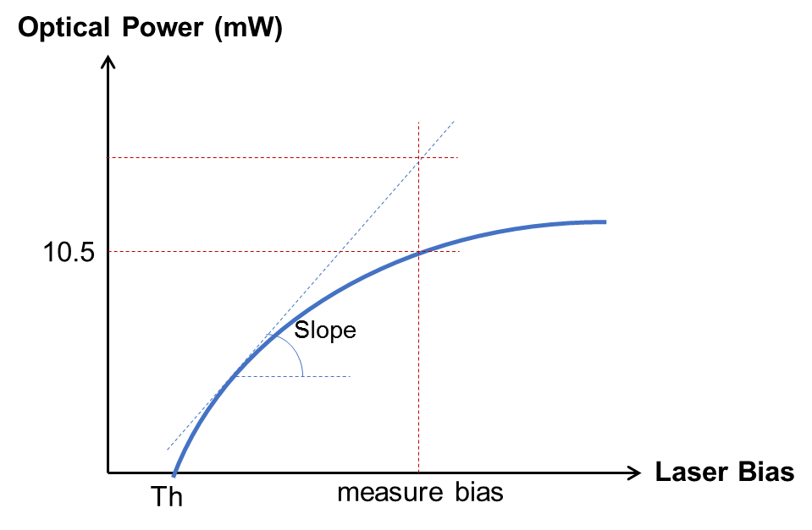
As it is clear, we have the minimum of Th for the laser bias to receive an optical power out of laser. This parameter is the same as ThrCurr (ThresholdCrrt) in our laser module measurements. Moreover, We have the Slope which shows the variations of optical power vs laser bias in the linear region of the curve. This parameter is exactly what measure at SlopEff (Slope Efficiency). As we see and our analysis shows, the laser bias in current process of tuning mostly depends on the ThresholdCrrt and Slopeff of the laser module. In order to investigate more to get the confidence on our result, we can implement few analysis. The first analysis would be to estimate the laser optical power based on ThrCrrt, SlopEff, and laser bias and compare it to our measured optical power which is 10.5 mW with very small variations for all the modules. In other words, we estimate the optical power only using the linear equation as:
OpticalPower(mW) = (SlopEff) * ( LaserBias – ThresholdCrrt)
The above equation only considers a linear relation between the optical power and laser bias. However, in most of the cases, we have a nonlinear relationship between these parameters. To consider the nonlinearity, we can use the following equation as a nonlinear estimate for the optical power. It should be noted that this equation is obtained intuitively based on the saturation of the curve.
$$OpticalPower=\sqrt[p]{LaserBias-ThresholdCrrt}$$
We use the parameter of p for our estimation and try to match it to our data. p varies between 1.7 and 1.8, and we use 1.75, the mean for this purpose.
If we use the above equations and calculate the optical power, we get the following histograms of the optical power for the laser modules data.
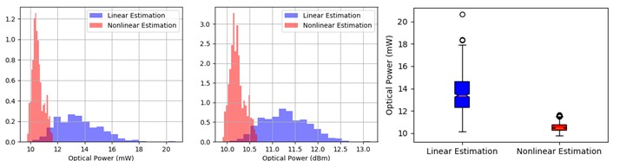
As we see, using the linear equation for optical power estimation, we get some wider variations for this feature compare to the nonlinear estimation. Using linear equation, the optical power is estimated higher than the actual value of 10.5 mW. This is also confirmed with the curve of optical power versus laser bias.
We could probably predict optical power correctly using our analysis based on the original idea of power vs bias curve. On the other side, we need to predict the laser bias. Let’s use the above equations but for predicting the laser bias. For the optical power, for the linear estimation, we need to use the average power of 13.54 mW instead of 10.5mW because our estimation provides higher value than the actual one. And for the nonlinear estimation, we can use the same optical power of 10.5 mW since our estimation provided an accurate value for the optical power. If we use such an analysis, we get the following results.
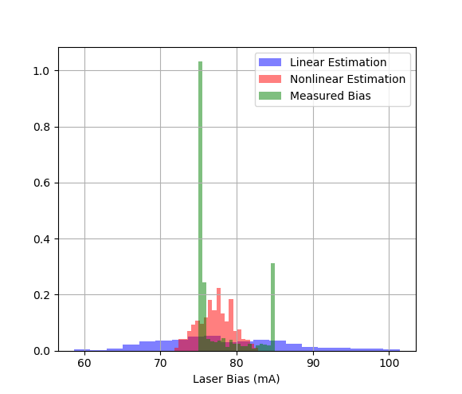
Based on this result, we observe that our estimations are not the same as the actual measurements. There could be different reasons for that. As we see our measured bias starts from 75 mA but our estimations goes lower than this value. The reason is simple. In our actual measurement for the laser bias, we start from 75mA and go up to 85mA. In fact, there might be some lasers that would require less laser bias in theory but we drive them with higher values. If we apply the same rule for our estimates, we get the following histograms:
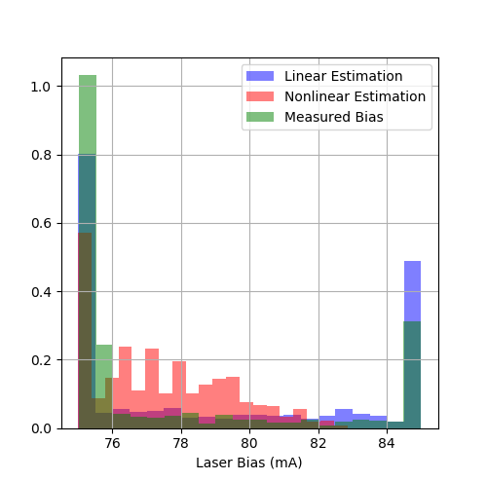
It seems like that we get similar patterns. But let’s plot the new estimated bias vs actual measured bias.
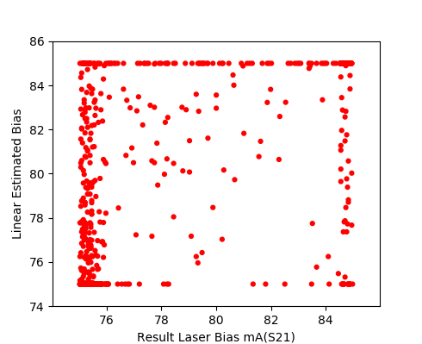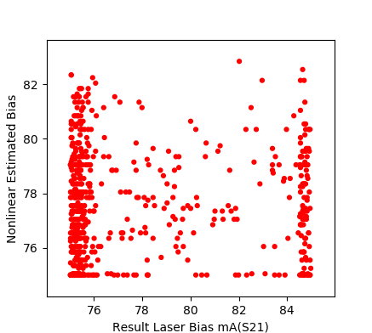
It seems like that our both linear and nonlinear estimations are not accurate.
So far, we found that ThresholdCrrt and Slopeff are two main factors in determining the laser bias. On the other hand they are not the only factors. Probably the following figure could explain the conclusion so far.
In general, small Slopeff leads to higher laser bias. But, the value of the laser bias depends on the total curve. For example, for some of the lasers, probably we operate them in saturation region and for some in the linear region. Also, it should be note that the laser bias value that the Slopeff is measured is very important as well. If this value is close to the ThresholdCrrt, or close to the saturation level, we might lose some important parameters for laser bias prediction. Probably measuring the SlopEff at three points on the curve could help a lot.
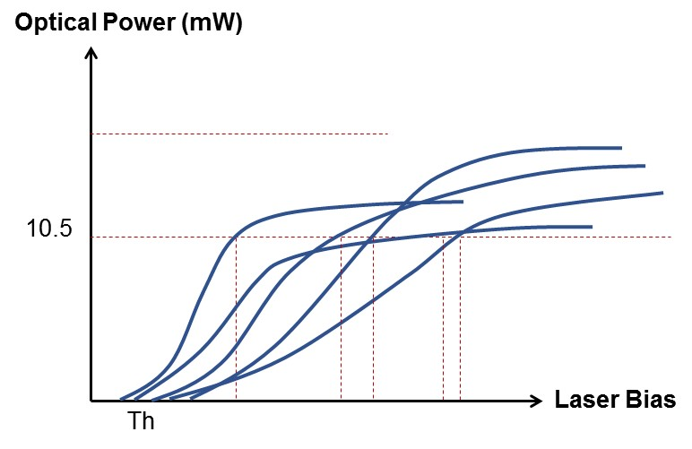
In fact, after discussing with Sr. ME, Jacqueline Li, we found that we can have the data for all the points on the curve. Following is one of the curves.
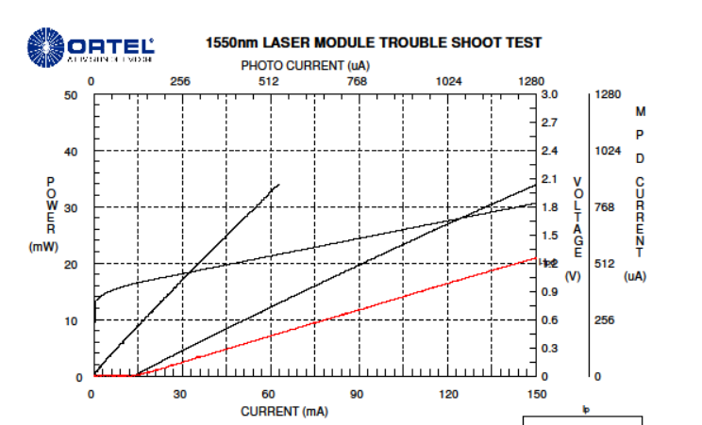
As a conclusion, we could mention that our current laser bias setting for the transmitter test is based on the optical power of the laser. It means that we tune the laser bias until we reach to specific optical power of 10.5 mW and then we never change the bias. Since, we only tune the bias to meet the optical power requirement, we can use the optical power vs laser bias curve measured from laser module test station to set the initial point for the bias at the transmitter test station. In this way we don’t need to tune a large range.
Regarding the impact of the laser bias on the BER test, our current intuition is probably with the current data set we might not be able to find the relationship because the bias at the current stage only set to meet the optical power threshold not any other feature. However, it might be helpful to investigate more on this issue to see if there is any correlation between the current laser bias data and BER test results. In the next short report, we will investigate the importance of laser bias in BER test.
It should be noted that if we couldn’t find this relationship, we probably would need to consider other tests to measure the correlation between the laser bias and BER test because our current laser bias data is achieved only by reaching the optical power threshold. We should note that other tests might be something like the relation between optical power and BER test which is called BER curve for most of the communication systems. If we could have such a curve, we might be able to find our more the BER pass/fail because we have the full curve of optical power vs laser bias in the laser module station as well as some SMSR measurement at different bias at the laser module station. So, measuring the BER curve probably could be helpful.

